How to make a sloping rounded roof

Let´s try something like this. A rounded roof sloping to one of the gables.
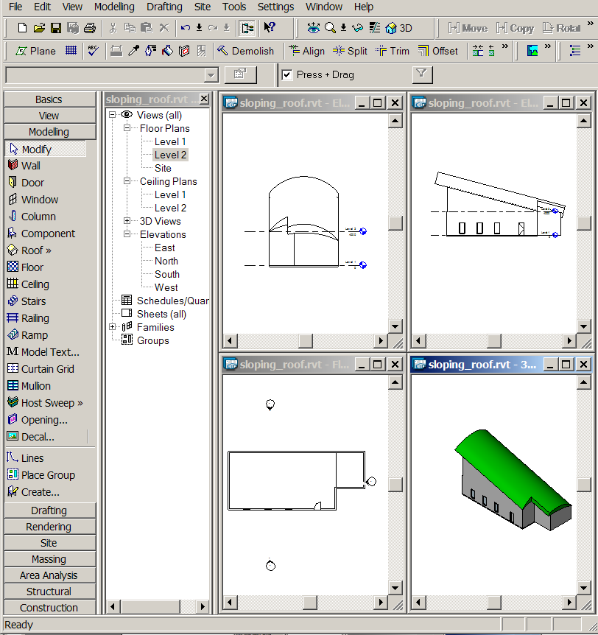

Start with some walls, windows…. Something like this.
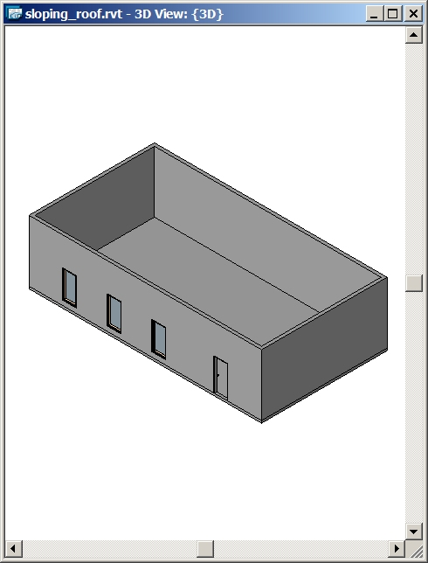

Choose Create on the Modelling tab of the Design Bar. And then choose the Family Category - Roofs.

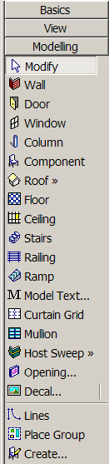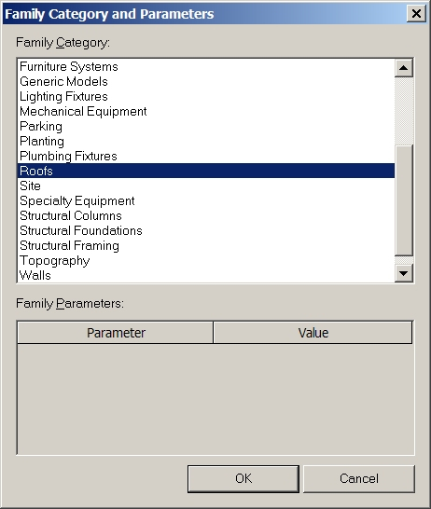

Name it to something fancy or just accept the default name.
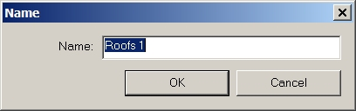

Choose Solid on the Design Bar and then Sweep.
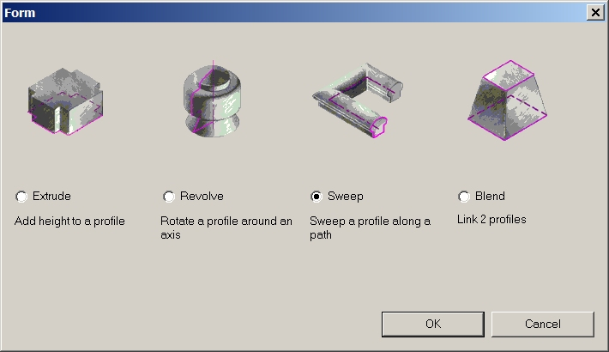

Click Sketch 2D Path on the Design Bar
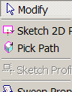

Click the Plane-button or click Set Work Plane on the Design Bar or on the menu Tools > Work Plane > Set Work Plane. And choose to Pick a Plane.
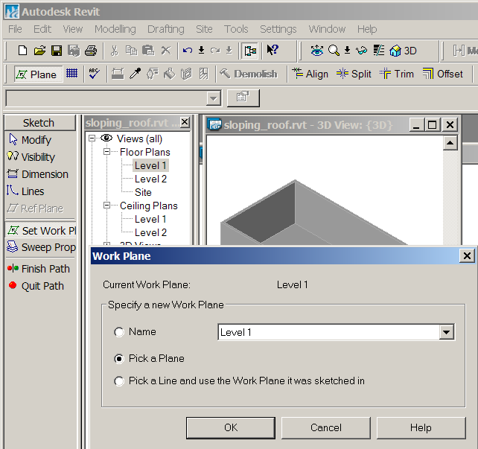

I choosed to pick the façade with the windows.
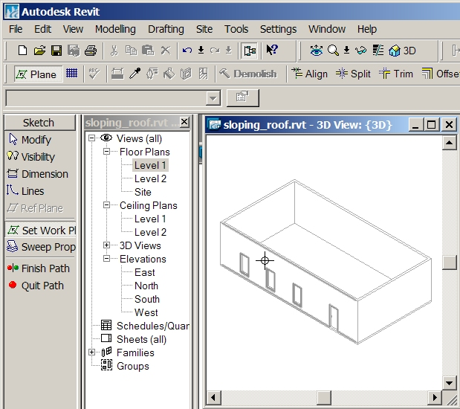

Draw a sloping line in the South Elevation
And then click Finish Path
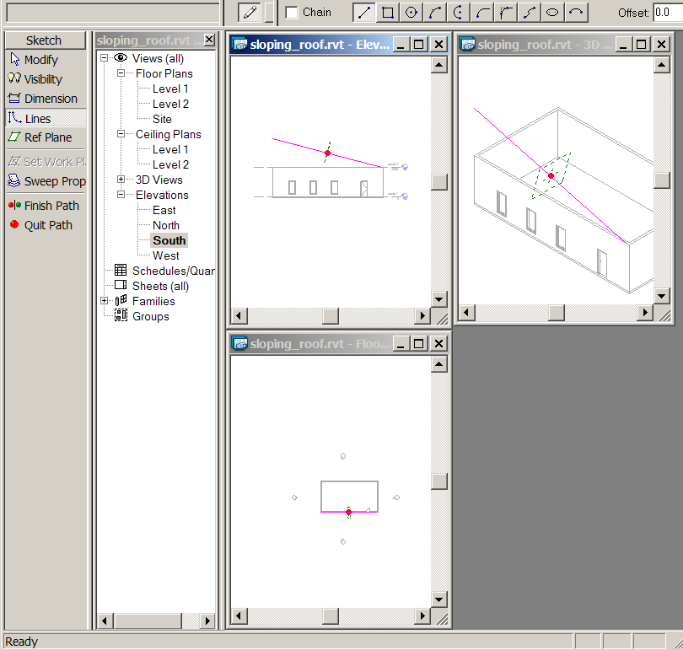

Now click Sketch Profile on the Design Bar and choose some view
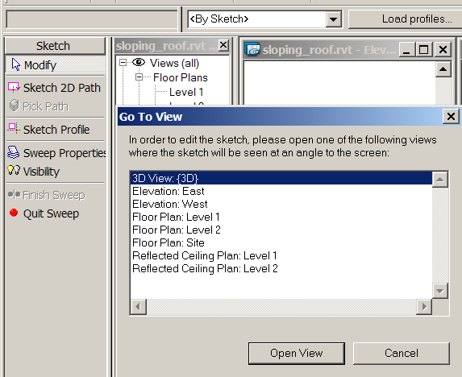

Click Line on the Design Bar. I used Arc passing through three points to make two interconnected curves. Click Finish Profile.
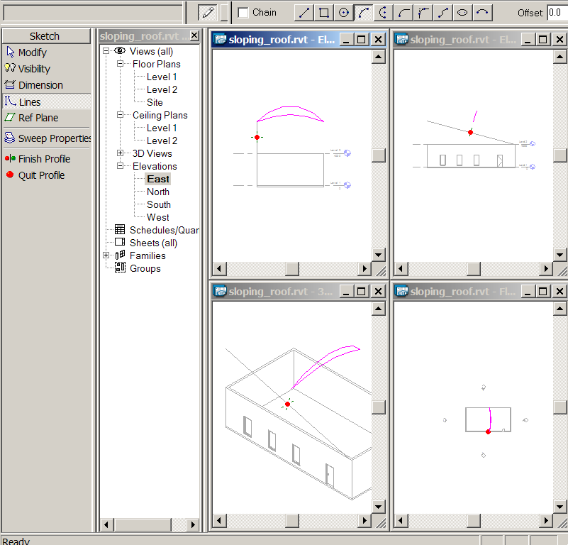
Then I clicked Finish Sweep and got this.
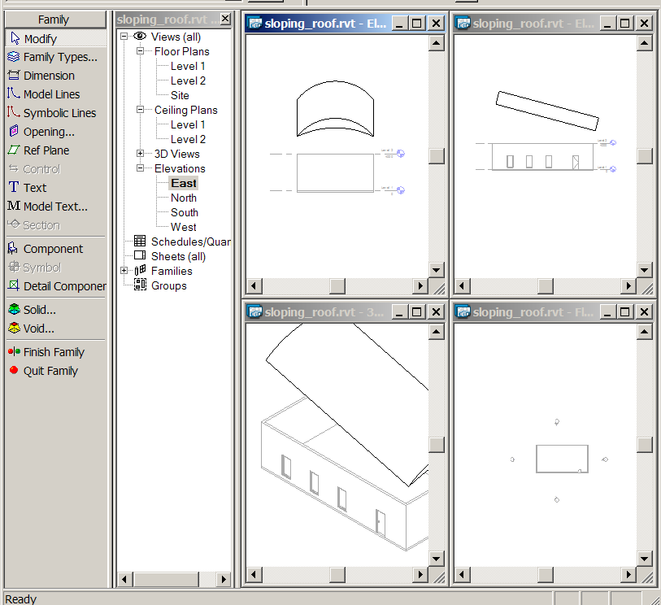

I could now move the roof a bit down. I discovered that I needed a roof that was a bit longer so I clicked the button Edit with the roof selected.
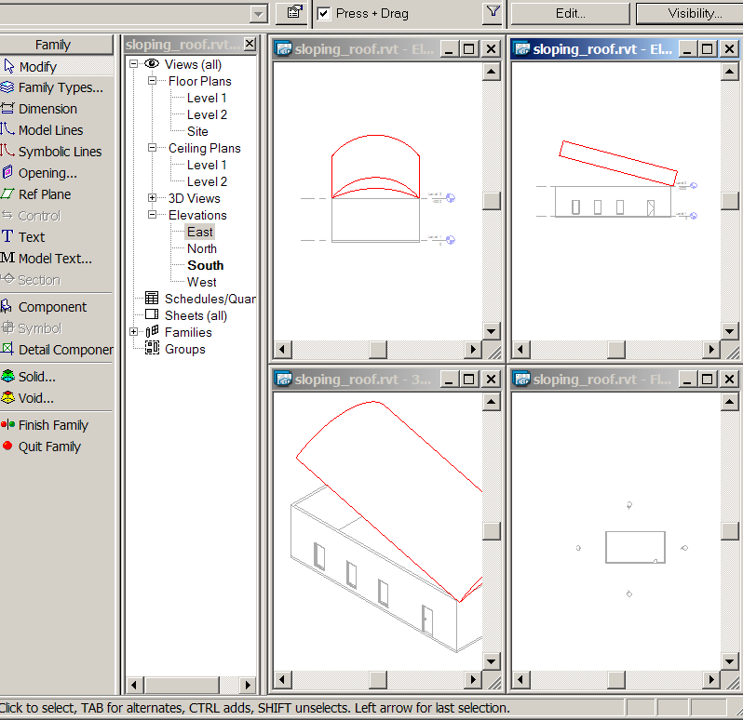

And then I clicked Sketch 2D Path and I could make the path a bit longer
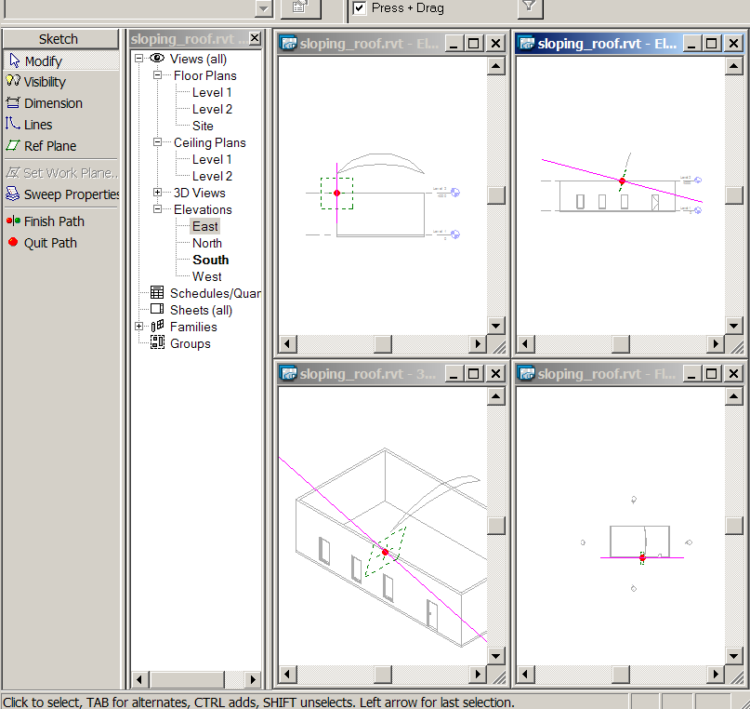
And then Finish Path and Finish Sweep. Now I choosed Void and then Extrude to cut a bit out of the roof. And I choosed Level 1.
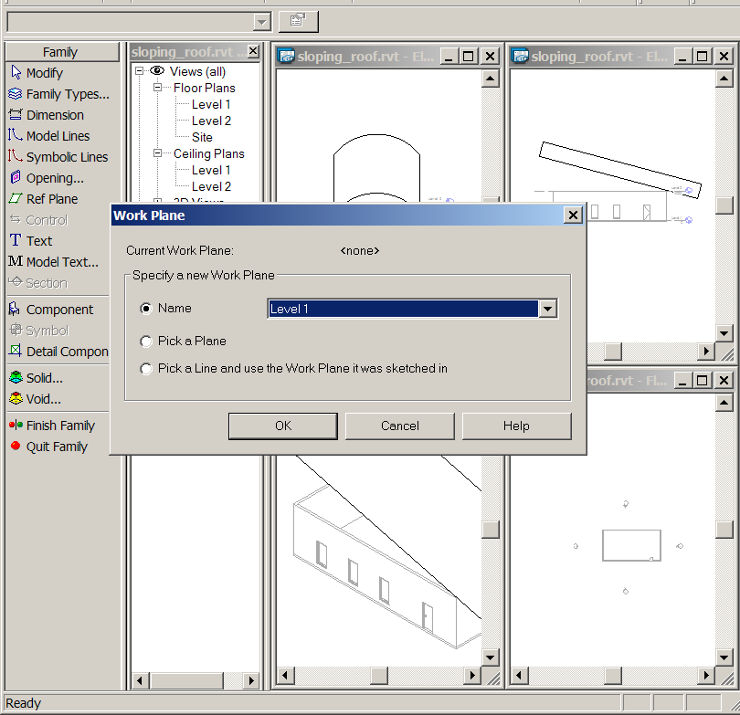

And Lines on the Design Bar and sketched a Rectangle.

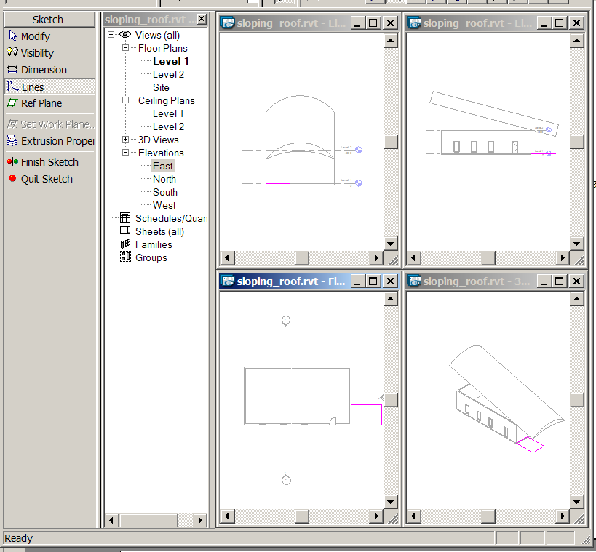

Then Finish Sketch and I could use the arrows on the Void to make it cut out the part of the roof I wanted.
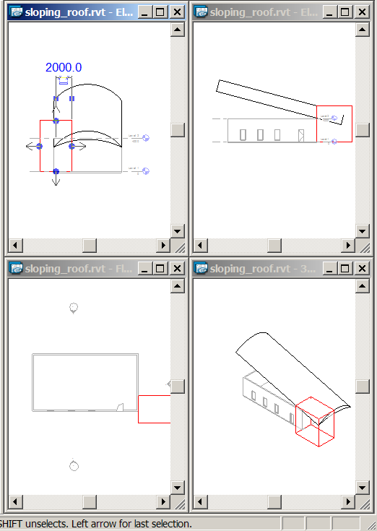

And I could select a wall and then click the Button Attach and click the roof.
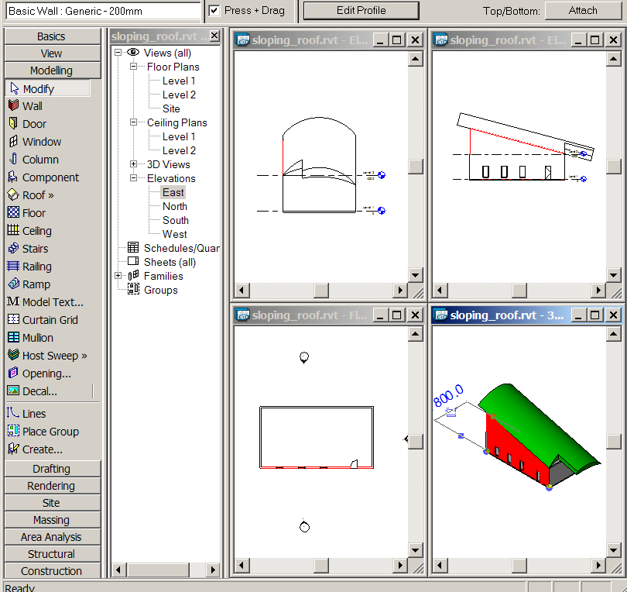

And go on to make some new walls under the roof and attaching them.

