REVIT

Street Work Tutorial

Prepare a basic geometry for the proposed street this can be survey lines from imported drawings or self generated. Establish the relative positions of your driveway approaches.

Set up the following work planes and framing views

Station sections:

Begin
Begin Curve (radial)
Begin drive X (radial)
Begin drive approach (radial)
End drive approach (radial)
End drive X (radial)
End Curve (radial)
End

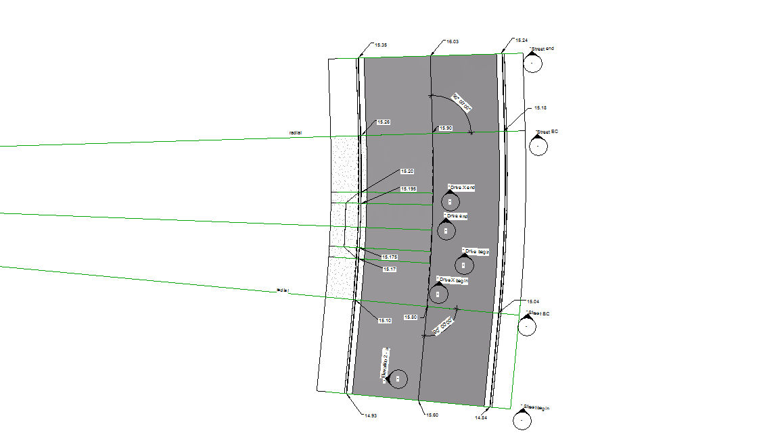

These work planes are on radial as the street and driveway approach are on the curve. This particular portion of street is a relatively straight slope although the elevations used at each cross section were developed from the original imported survey data. 16 Solid Sweep Blends in this portion of street.

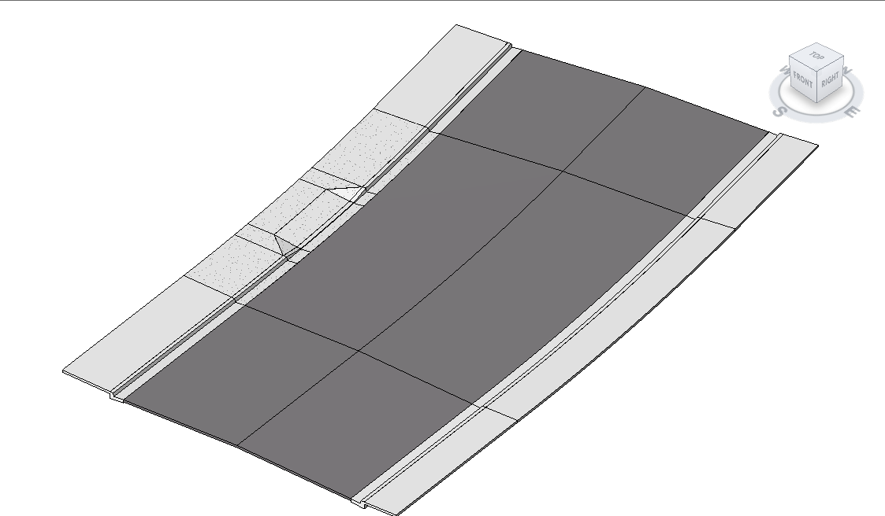

Then use the Solid Sweep Blend to create your path and cross sections and extrusions. The Solid Sweep Blend can only use one path at a time. The Solid Sweep Blend cannot use a straight portion of path and a curved portion of path at the same time. This model was created using centerline. Numerous sections will be needed to establish your model correctly. Adjust the elevation of each section height at each end of the path. Use the framing views to keep your sections square to the center line.
If the roadway is straight one could develop a vertical curve if needed, if the roadway has a vertical together with a horizontal curve one will have to do multiple section on the vertical curve much like the surveyor sets out stations, and the contractor works to those stations.

