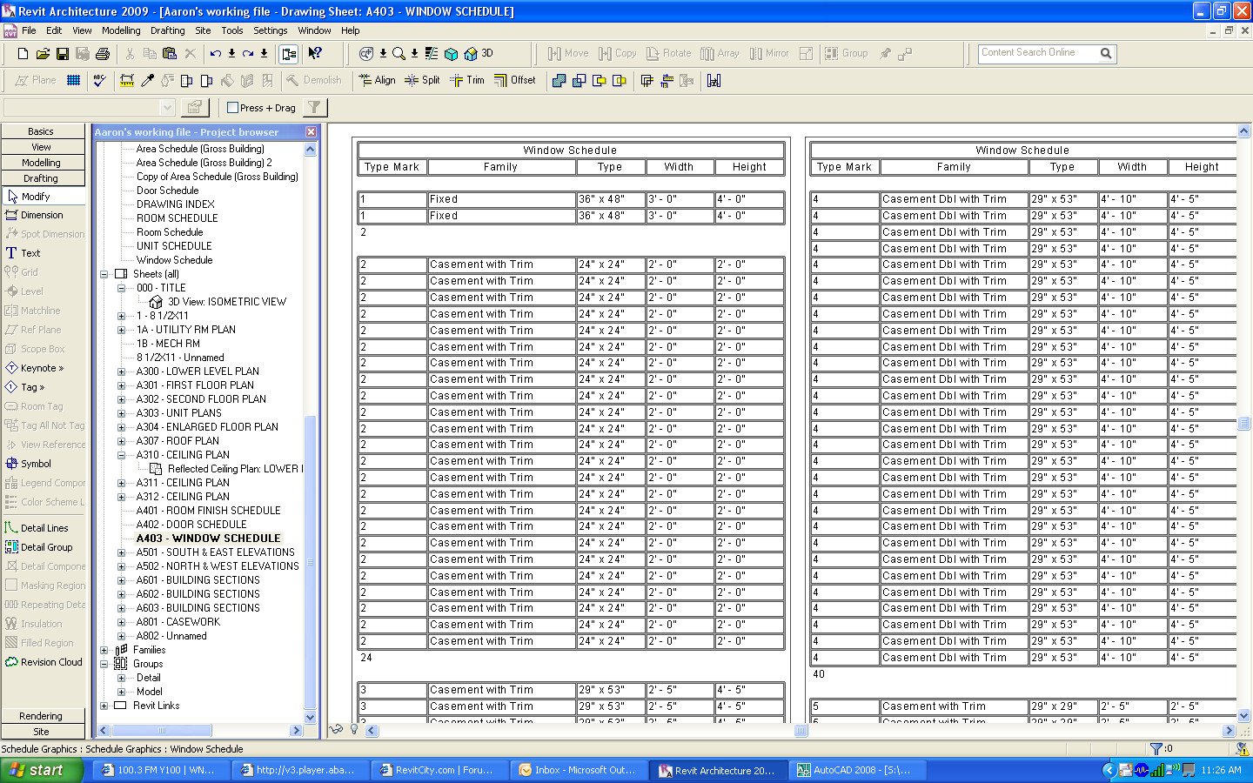

What I am looking for is something like this

Type Mark | Count (this is where I want the total | Family | Type | Width | Height
1 | 2 | Fixed | 36” x 48” | 3’-0” | 4’-0”
2 | 24 | Casement with Trim | 24” x24” | 2’-0” | 2’-0”
3 | 12 | Casement with Trim | 29” x 53” | 2’-5” | 4’-5”

